

**School of Engineering & Technology**

**Sharda University**

**College Database Management Project**

SRS Document

**Submitted By:**

Mohammad Tahir

2017015108

BCA (3rd year,5th Semester)

**INDEX**

Page no.

1. **Objective 3**
2. **Introduction 4**
3. **Abstract 5**
4. **Requirement Analysis 6**

**4.1. Functional Requirement 6**

**4.2. Hardware Requirement 6**

**4.3. Software Requirement 6**

1. **Use-Case Diagram 7**
2. **Data flow diagram (DFD)**   **8**
3. **Interface** **10**

**1.Objective**

The objective of this project to GUI (Graphical User Interface) based software i.e. platform independent & user friendly and which can be fitted into any college system. It will remove redundancy and will be fast in operation.

Features included in the application are: -

* **Reduced Data Redundancy**

As the software uses RDBMS (Relational Database Management System) in the backend of the application, so it will overcome the problems of data duplicacy.

* **Fast Execution**

As the application is GUI based and it contains many new features which will make the execution faster than any other pre-existing application.

* **Cost Efficient**

Due to the removal of data redundancy from the application, duplicacy of data is eliminated and wastage of memory is also overcome. As we know the storage device are cost consuming so by saving space, we are saving money

**2.Introduction**

The topic of the project is very diverse as it will manage a college which is itself a huge organization which impacts knowledge but for its proper working many other things work all the time along with studies.

The aim of this project is to manage each and every required section a software can handle with accuracy eliminating many mistakes that a person on job performs due to any reason and makes the operations even faster. Every department is a module and has independent working criteria but in one way or the other they are related with one other and collecting these modules a college is formed which need to be manage.

The modules that we need to work on:

* Accounts
* Academic
* Training & Placement
* Exam cell
* Library
* Laboratory
* Transportation
* Cultural

These are the modules which when managed properly a stable college management system is formed whose aim is to provide quality knowledge to its students and earn name and fame for itself and its students.

**3.Abstract**

An organized and systematic office solution is essential for all universities and organizations. There are many departments of administration for the maintenance of college information and student databases in any institution. All these departments provide various records regarding students. Most of these track records need to maintain information about the students. This information could be the general details like student name, address, performance, attendance etc. or specific information related to departments like collection of data.

In general, this project aims to enhance efficiency and at the same time maintain information accurateness.

The project will provide more ease for managing the data than manually maintaining in the documents. This project is useful for saving valuable time and reduces the huge paper work.

**4.Requirement Analysis**

**4.1Functional Requirements**

The function Requirements of the project are

* Admin Login
* Faculty Login
* Student Login
* Fee Management
* Couse Details
* Student’s Details
* Exam Management

**4.2. Hardware Requirements**

* Processor: Intel i5 and above
* Ram: 4 Gb ram and above
* Network Connection
* Disk Space(minimum): 10 GB

**4.3. Software Requirement**

* OS: Windows 7 and above
* .Net Framework
* Web Browser

**5.Use-Case Diagram**

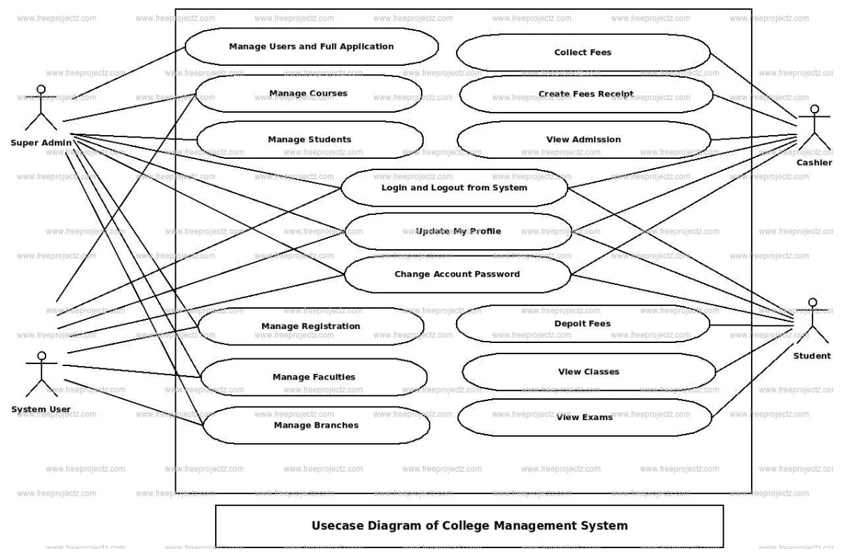

**6.Data flow Diagram**

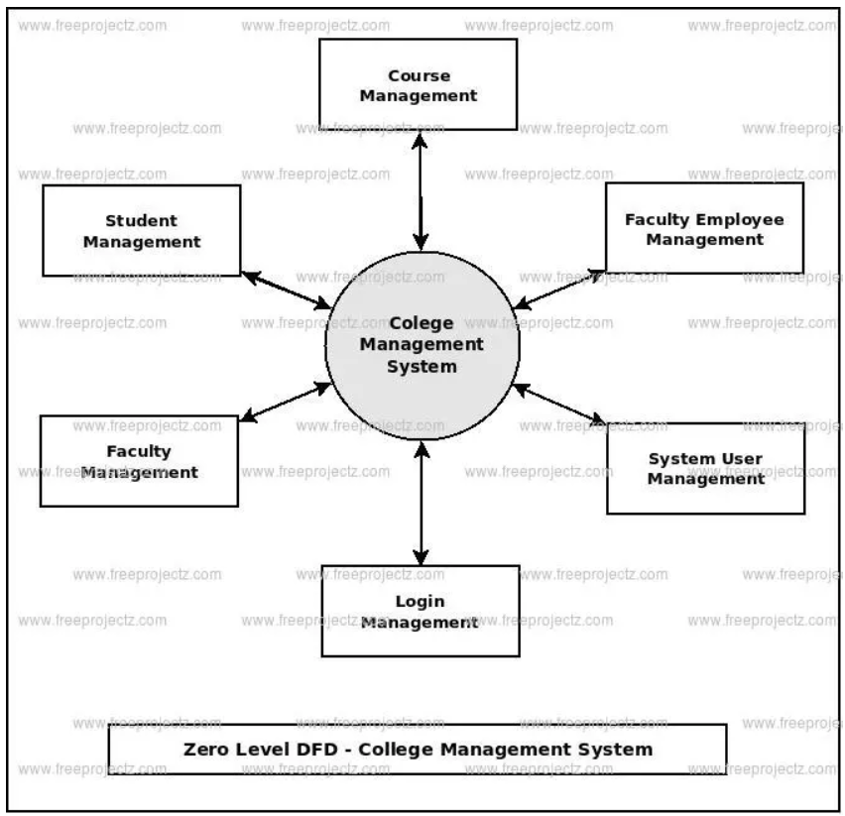

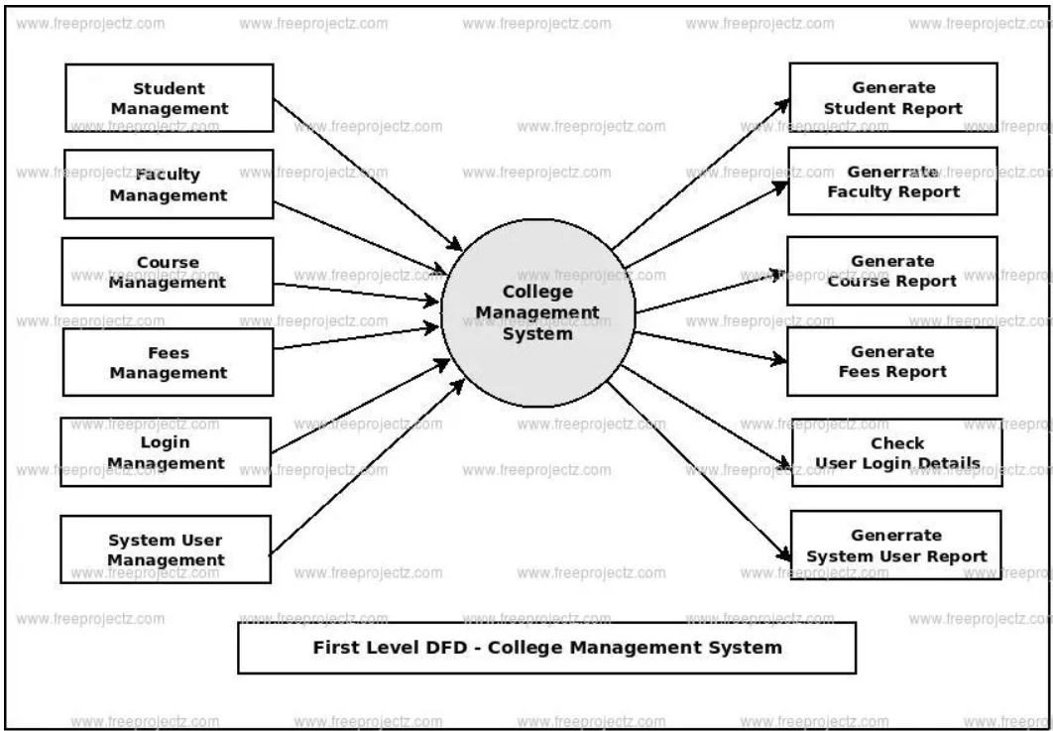

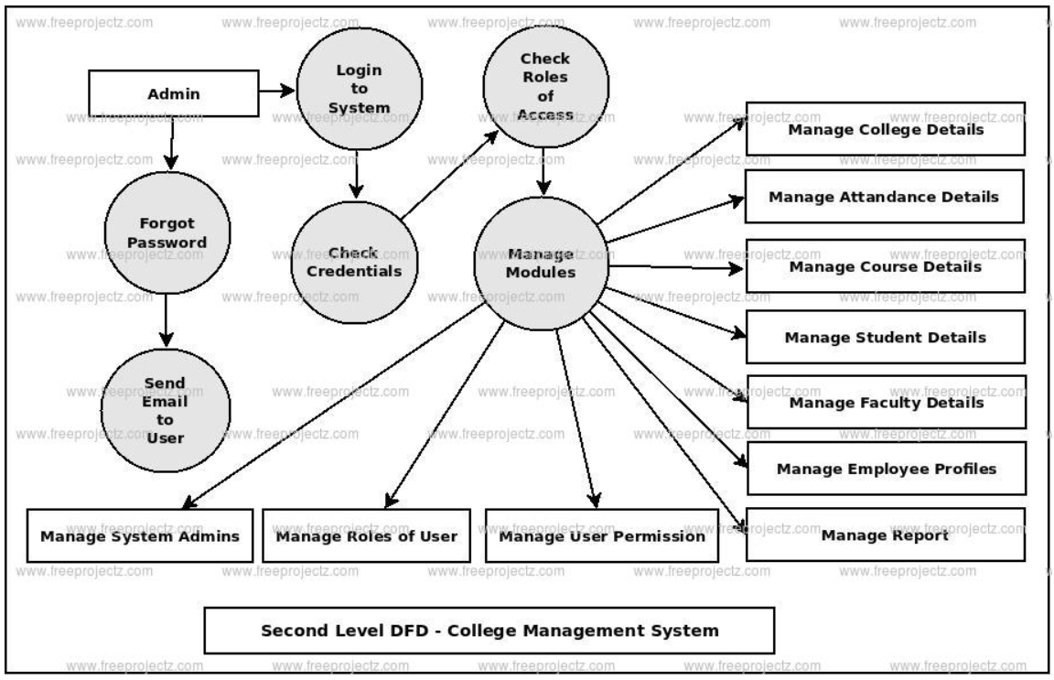

7.Interface

